SANGEET A MUSIC STREAMING

PLATFORM

### A PROJECT REPORT

**for**

**Mini Project-I (K24MCA18P) Session (2024-25)**

**Submitted by**

## **Deepak Sharma**

## **(202410116100055)**

**Devansh Kumar**

**(202410116100059)**

## **Avnish Kaushik**

## **(202410116100045)**

**Submitted in partial fulfilment of the Requirements for the Degree of**

MASTER OF COMPUTER APPLICATION

**Under the Supervision of Ms. Divya Singhal Assistant Professor**



**Submitted to**

**Department Of Computer Applications**

**KIET Group of Institutions, Ghaziabad Uttar Pradesh-201206**

**(DECEMBER- 2024)**

# CERTIFICATE

Certified that, Deepak Sharma, Avnish Kaushik**,** Devansh Kumar has carried out the project work having “**SANGEET THE MUSIC STREAMING PLATFORM**” (**Mini Project-I, K24MCA18P**) for **Master of Computer Application** from Dr. A.P.J. Abdul Kalam Technical University (AKTU**)** (formerly UPTU), Lucknow under my supervision. The project report embodies original work, and studies are carried out by the student himself, and the contents of the project report do not form the basis for the award of any other degree to the candidate or to anybody else from this or any other University/Institution.

**Ms. Divya Singhal Dr. Arun Kr. Tripathi**

**Assistant Professor Dean**

**Department of Computer Applications Department of Computer Applications KIET Group of Institutions, Ghaziabad KIET Group of Institutions, Ghaziabad**

**ABSTRACT**

The "Sangeet Online Music Playing Platform" project is an innovative digital solution designed to redefine the music streaming experience by providing users with seamless access to an extensive collection of songs across various genres, languages, and cultures. This platform aims to create an immersive musical journey by integrating advanced search algorithms, personalized playlists, and intelligent recommendation systems.

The primary objective of the project is to deliver a user-centric music streaming service that caters to diverse preferences while fostering a connection with Indian and global music heritage. Leveraging cutting-edge technologies such as artificial intelligence, machine learning, and cloud computing, the platform offers features like curated playlists, mood-based music selection, and offline playback, ensuring an uninterrupted listening experience.

The Sangeet platform is designed to support a vast audience, from casual listeners to music enthusiasts, by providing high-quality audio, real-time streaming, and an intuitive user interface. Special emphasis is placed on promoting independent artists and regional music, thereby preserving cultural diversity and offering a stage for emerging talent.

Applications of this platform span multiple domains, including entertainment, wellness, and education. Through its integration with social sharing tools and live streaming options, Sangeet fosters a vibrant community of music lovers while empowering creators.

This project highlights the potential of technology to enhance cultural appreciation and build an inclusive, connected world through music. With a scalable and adaptive framework, the Sangeet platform can evolve to incorporate emerging technologies, enabling features such as voice interaction, virtual concerts, and global collaborations, ensuring its relevance in an ever-changing digital landscape.

**Keywords:**

* Online Music Streaming
* Personalized Playlists
* Artificial Intelligence in Music
* Music Recommendation Systems
* Promoting Regional Music

### ACKNOWLEDGEMENTS

Success in life is never attained single-handedly. My deepest gratitude goes to my project supervisor, **Ms. Divya Singhal,** for her guidance, help, and encouragement throughout my project work. Their enlightening ideas, comments, and suggestions.

Words are not enough to express my gratitude to Dr. Arun Kumar Tripathi, Professor and Dean, Department of Computer Applications, for his insightful comments and administrative help on various occasions.

Fortunately, I have many understanding friends, who have helped me a lot with many critical conditions.

Finally, my sincere thanks go to my family members and all those who have directly and indirectly provided me with moral support and other kinds of help. Without their support, completion of this work would not have been possible in time. They keep my life filled with enjoyment and happiness.

**Deepak Sharma**

**Avnish Kaushik**

**Devansh Kumar**

**INDEX**

**TABLE OF CONTENTS PAGE NO.**

Certificate ii

Abstract iii

Acknowledgements iv

Index v

1. Introduction 1
   1. Overview 1
   2. Background and motivation 1
   3. Objective 2
   4. Scope of the project 3
2. Feasibility study 4
   1. Technical Feasibility 4
   2. Economic Feasibility 4
   3. Existing Solutions and Literature 5
   4. Gaps in Existing Systems 5
   5. Social and Practical Feasibility 6
3. Project objective 7
   1. Key Objectives 7
   2. Broader Objectives 9
   3. Measurable Outcomes 10
4. Hardware and software requirements 11
   1. Hardware Requirement 11
   2. Software Requirements 12
5. Project flow 14
   1. User Authentication Stage 14
   2. User Input Stage 14
   3. Input Parser Stage 15
   4. Sign Language Mapping Stage 15
   5. Animation Playback Stage 15
   6. Output Stage 15
   7. DFD 16
   8. Use Case Diagram 17
   9. Flowchart & Algorithm 18
6. Project outcome 19
   1. Key Outcomes 19
   2. Social Impact 20
   3. Technological Advancement 20
7. User Interface 21

References 28

**CHAPTER 1**  
**INTRODUCTION**

### ****1.1 OVERVIEW****

The "Sangeet Online Music Playing Platform" project aims to revolutionize the music streaming experience by offering users an intuitive, personalized, and accessible platform for enjoying music. With a vast collection of songs spanning multiple languages, genres, and cultural backgrounds, the platform is designed to cater to diverse musical preferences. By leveraging advanced technologies such as artificial intelligence and machine learning, Sangeet enables seamless music discovery, mood-based playlists, and intelligent recommendations.

Music serves as a universal language that transcends barriers and connects people worldwide. While the music industry has seen substantial growth in digital streaming platforms, challenges such as limited regional content, lack of artist support, and non-personalized user experiences remain prevalent. The proposed Sangeet platform seeks to address these gaps by providing a comprehensive solution that not only enhances user satisfaction but also fosters a deeper appreciation for diverse musical cultures.

### ****1.2 BACKGROUND AND MOTIVATION****

The increasing adoption of digital platforms for entertainment highlights the need for a music streaming solution that is inclusive, culturally enriching, and user-friendly. While several global players dominate the music streaming space, there is a lack of platforms that emphasize regional content and independent artists while ensuring a personalized experience for users.

#### **1.2.1 Existing Challenges**

1. **Lack of Regional and Independent Artist Representation:**  
   Many existing platforms focus heavily on mainstream music, leaving regional and independent artists underrepresented.
2. **Limited Personalization:**  
   Users often encounter generic playlists or recommendations that do not cater to their unique preferences or listening habits.
3. **Accessibility Issues:**  
   High subscription costs and limited offline playback features restrict access for many users, particularly in rural or underserved areas.
4. **Absence of Community Engagement:**  
   Current platforms rarely provide opportunities for music lovers to connect, share, and engage within a vibrant community.

#### **1.2.2 Motivation for the Project**

The Sangeet platform is motivated by the need to address these challenges and create a music streaming service that:

* Provides access to an extensive library of songs, including regional and independent music.
* Utilizes advanced recommendation algorithms for a highly personalized user experience.
* Promotes affordability and accessibility, ensuring that users from all demographics can enjoy the platform.
* Encourages social engagement through features like playlist sharing and live-streamed performances.

### ****1.3 OBJECTIVES****

The main objectives of the Sangeet Online Music Playing Platform project are:

1. To develop a robust and user-friendly music streaming platform that provides a seamless listening experience.
2. To implement personalized recommendation systems using machine learning for tailored playlists and suggestions.
3. To promote regional and independent artists by featuring their music prominently on the platform.
4. To ensure accessibility through affordable pricing, offline playback options, and multilingual support.
5. To integrate features such as mood-based playlists, curated content, and community engagement tools for an enhanced user experience.
6. To create a scalable and adaptive platform capable of incorporating future technologies like virtual concerts and AI-driven music composition.
7. To foster a cultural appreciation for diverse music traditions, making Sangeet a platform that celebrates music as a universal medium of connection.

### ****1.4 Scope of the Project****

The scope of the "Sangeet Online Music Playing Platform" project includes:

1. **Extensive Music Library:**
   * Incorporation of a vast collection of songs across multiple languages, genres, and cultural backgrounds.
   * Support for regional and independent artists by prominently featuring their music.
2. **Personalized Recommendations:**
   * Implementation of advanced recommendation algorithms using machine learning to provide tailored playlists and song suggestions.
   * Mood-based music selection and dynamic playlist generation based on user preferences and listening habits.
3. **User-Friendly Interface:**
   * Designing an intuitive and visually appealing interface using modern web technologies like HTML, CSS, and JavaScript.
   * Ensuring a seamless user experience across devices, including mobile and desktop platforms.
4. **Offline Playback and Accessibility:**
   * Enabling offline playback for users with limited internet access.
   * Providing affordable subscription plans and ensuring multilingual support for wider accessibility.
5. **Community Engagement:**
   * Integration of features like playlist sharing, live music streaming, and social interactions to build a community of music enthusiasts.
   * Promoting user-created playlists and encouraging collaborative music discovery.
6. **Scalability and Future Enhancements:**
   * Building a flexible system architecture to accommodate future features like virtual concerts, AI-generated music, and voice-command-based navigation.
   * Expanding the platform’s capabilities to integrate emerging technologies and trends in the music industry.

### ****CHAPTER 2****

**FEASIBILITY STUDY**

### ****2.1 Technical Feasibility****

The technical feasibility assesses whether the "Sangeet Online Music Playing Platform" can be implemented using available technologies, tools, and frameworks:

* **Music Streaming and Storage:**  
  Utilizing cloud-based storage solutions like AWS or Google Cloud for hosting and streaming a vast library of music efficiently.
* **Recommendation Systems:**  
  Leveraging machine learning frameworks such as TensorFlow or Scikit-Learn for building personalized recommendation models.
* **User Interface and Experience:**  
  Frontend development using modern web technologies like ReactJS, HTML5, CSS3, and JavaScript ensures a responsive and intuitive interface across devices.
* **Backend Development:**  
  Employing robust backend frameworks such as Django or Node.js to manage user data, playlists, and streaming services securely.
* **Scalability and Load Management:**  
  Using scalable architectures like microservices and CDN (Content Delivery Networks) to handle high traffic and ensure uninterrupted streaming.

### ****2.2 Economic Feasibility****

This subsection evaluates the cost-effectiveness of the project:

* **Cost of Development:**  
  The use of open-source tools like Python, ReactJS, and free-tier cloud services during initial development reduces costs significantly.
* **Infrastructure Costs:**  
  Cloud-based solutions allow cost optimization with pay-as-you-go models, making the platform affordable to develop and maintain.
* **Revenue Generation:**  
  The platform can generate revenue through:
  + Subscription-based models with tiered pricing for premium features (e.g., ad-free listening and offline playback).
  + Advertisements for free-tier users.
  + Partnerships with independent artists and record labels for promotions.
* **Return on Investment (ROI):**  
  With a growing demand for online music platforms, Sangeet has high potential for ROI through a combination of user subscriptions and ad revenues.

### ****2.3 Existing Solutions and Literature****

Current music streaming platforms include global giants like Spotify, Apple Music, and regional competitors like JioSaavn and Gaana. These platforms focus on delivering a large music library and basic personalization features.

* **Strengths of Existing Solutions:**
  + Extensive music libraries.
  + User-friendly interfaces.
  + Integration of AI-driven recommendations.
* **Weaknesses:**
  + Limited focus on regional music and independent artists.
  + Expensive premium plans for wider access to features.
  + Generic personalization features that often lack depth.

Research on recommendation systems and user behavior analysis highlights the importance of hyper-personalized music discovery. Platforms with stronger focus on regional music or community-building features remain underexplored, creating a niche opportunity for Sangeet.

### ****2.4 Gaps in Existing Systems****

Despite the success of global and regional music streaming platforms, several gaps remain:

1. **Regional and Independent Music:**  
   Existing platforms often underrepresent regional languages and independent artists, leaving untapped potential for cultural and creative promotion.
2. **Community Engagement:**  
   Few platforms emphasize user interaction through playlist sharing, collaborative playlists, or live music experiences.
3. **Accessibility:**  
   High subscription costs and limited offline playback restrict access for users in rural or underserved areas.
4. **Personalization Depth:**  
   Current recommendation systems often fail to provide deeply personalized experiences tailored to niche preferences or evolving listening habits.

This project addresses these gaps by:

* Prioritizing regional and independent music alongside mainstream content.
* Offering affordable pricing models and offline playback for better accessibility.
* Enhancing community engagement through social and collaborative features.
* Implementing advanced, AI-driven personalized recommendations.

### ****2.5 Social and Practical Feasibility****

The social and practical feasibility evaluates the project's real-world applicability and benefits:

1. **Impact on Music Communities:**
   * Provides a platform for independent artists to reach wider audiences, supporting their growth.
   * Promotes regional and cultural diversity in music.
2. **Enhanced User Experience:**
   * Enables personalized listening through mood-based and curated playlists.
   * Builds a community of music enthusiasts who can interact, share, and collaborate.
3. **Accessibility for Diverse Users:**
   * Affordable plans and multilingual support make the platform accessible to users across various socioeconomic and linguistic backgrounds.
   * Offline playback ensures usability in areas with limited connectivity.
4. **Scalability:**
   * The platform’s architecture is designed to accommodate future technologies such as virtual concerts, voice-command navigation, and AI-generated music, ensuring its relevance in an evolving digital landscape.

### ****CHAPTER 3****

**PROJECT OBJECTIVE**

The primary objective of the "Sangeet Online Music Playing Platform" is to create a versatile, inclusive, and engaging music streaming platform that caters to the diverse needs of music enthusiasts. The project aims to redefine the user experience in online music streaming by offering personalized recommendations, seamless access to music across genres, and a focus on regional and independent artists.

### ****3.1 Key Objectives****

1. **Extensive Music Library**
   * Provide users access to a vast collection of songs spanning various languages, genres, and cultural traditions.
   * Integrate support for regional music and independent artists to promote inclusivity and cultural diversity.
   * Ensure constant updates to the library with trending tracks and curated playlists.
2. **Personalized Recommendations**
   * Implement advanced recommendation algorithms using machine learning to tailor music suggestions based on user preferences.
   * Offer mood-based and activity-specific playlist generation to enhance user satisfaction.
   * Adapt dynamically to users' evolving tastes through continuous learning models.
3. **User-Friendly Interface**
   * Design a modern, responsive, and intuitive interface suitable for users of all age groups and technical proficiencies.
   * Optimize navigation to simplify playlist creation, song search, and playback controls.
   * Include features like dark mode, customizable themes, and multi-device synchronization for a better user experience.
4. **Offline Playback and Accessibility**
   * Enable offline playback for users with intermittent internet connectivity.
   * Provide affordable subscription plans to ensure the platform is accessible to users from all socioeconomic backgrounds.
   * Support multilingual interfaces for users in diverse linguistic regions.
5. **Community Engagement**
   * Develop features for playlist sharing, collaborative playlist creation, and social interactions to foster a community of music lovers.
   * Organize virtual events, live music streaming, and artist showcases to encourage user participation and artist engagement.
6. **Cost-Effective and Scalable Solution**
   * Use open-source technologies and cloud-based storage to minimize development and operational costs.
   * Build a scalable architecture that supports the integration of new features such as AI-generated music, live streaming, and voice-activated controls.
   * Design the platform to handle high user traffic efficiently while maintaining seamless performance.
7. **Regional Music Promotion**
   * Promote regional and independent artists by giving them a dedicated space on the platform.
   * Develop partnerships with local artists and music labels to expand the reach of culturally significant music.
   * Feature curated playlists that highlight regional talent and unique genres.

### ****3.2 Broader Objectives****

1. **Innovation in Music Streaming:**
   * Use state-of-the-art technologies to create an engaging and innovative music streaming experience for users.
2. **Inclusivity in Music Access:**
   * Ensure that users from diverse linguistic, cultural, and economic backgrounds can access and enjoy music.
3. **Community and Artist Support:**
   * Provide a platform that connects artists with their audience, fostering creativity and engagement within the music community.
4. **Scalable and Future-Ready:**
   * Design the platform to accommodate emerging trends in music streaming, such as immersive audio, virtual reality concerts, and AI-powered music curation.
5. **Global Reach with Local Focus:**
   * While aiming for a global audience, retain a strong focus on promoting local music and culture to create a distinctive niche.

### ****3.3 Measurable Outcomes****

1. **User Growth and Retention:**
   * Track the number of active users, subscription rates, and retention levels to measure platform success.
2. **Recommendation System Accuracy:**
   * Evaluate the accuracy and effectiveness of personalized recommendations through user feedback and engagement metrics.
3. **Artist Impact:**
   * Measure the platform's contribution to the promotion of regional and independent artists by tracking their streams and audience reach.
4. **Platform Performance:**
   * Ensure low latency, minimal downtime, and smooth functionality across devices to maintain a high-quality user experience.
5. **Inclusivity Index:**
   * Assess the platform's success in reaching underserved audiences and promoting cultural diversity through music offerings.

### ****CHAPTER 4****

**HARDWARE AND SOFTWARE REQUIREMENTS**

### ****4.1 Hardware Requirements****

To develop, test, and deploy the "Sangeet Online Music Playing Platform," the following hardware components are necessary:

1. **Processor (CPU):**
   * A system with at least an Intel Core i5 processor (or equivalent) to efficiently handle music streaming, server requests, and recommendation algorithms.
2. **Memory (RAM):**
   * A minimum of 8 GB RAM is recommended to manage simultaneous tasks such as streaming, database queries, and real-time recommendation computations.
3. **Storage:**
   * At least 500 GB of storage (SSD preferred) to accommodate music files, user data, and platform resources.
   * Scalable storage options such as cloud-based storage for growing music libraries.
4. **Audio Equipment:**
   * High-quality speakers or headphones for testing audio playback and ensuring superior sound quality.
5. **Display:**
   * A screen with a minimum resolution of 1920x1080 for developing and testing the user interface and visual elements.
6. **Internet Connection:**
   * A stable and fast internet connection to enable seamless music streaming, API interactions, and real-time data fetching.
7. **Input Devices:**
   * Basic peripherals such as a keyboard and mouse for user interaction during development and testing phases.
8. **Server Requirements (for deployment):**
   * A server with at least 4 vCPUs and 8 GB RAM for hosting the application, database, and streaming services.

### ****4.2 Software Requirements****

The following software tools and frameworks are required to implement the "Sangeet Online Music Playing Platform":

1. **Operating System:**
   * Windows 10/11, Ubuntu Linux, or macOS
   * A reliable and developer-friendly operating system to support backend, frontend, and deployment tools.
2. **Backend Frameworks and Tools:**
   * **Python (3.7 or higher):** The core programming language for backend development.
   * **Django Framework:** To handle server-side logic, user authentication, and API integration.
   * **Flask (Optional):** For building microservices or lightweight modules.
3. **Frontend Development Tools:**
   * **HTML5, CSS3, and JavaScript:** Core technologies to design the platform's interface.
   * **React.js or Vue.js:** Modern JavaScript frameworks for building dynamic and responsive user interfaces.
   * **Bootstrap:** A framework to ensure clean, responsive, and mobile-friendly designs.
4. **Music Streaming and Media Tools:**
   * **FFmpeg:** For audio encoding, decoding, and format conversions.
   * **HTML5 Audio Player:** For seamless music playback in web browsers.
   * **Cloud Storage Services (e.g., AWS S3, Google Cloud):** To store and stream music files securely.
5. **Database Management System:**
   * **PostgreSQL or MySQL:** To handle large datasets, including user profiles, playlists, and music metadata.
   * **SQLite:** For lightweight development and testing purposes.
6. **Recommendation System Libraries:**
   * **Scikit-learn or TensorFlow:** To implement machine learning models for personalized recommendations.
   * **Pandas and NumPy:** For data processing and analysis.
7. **Development Environment:**
   * **Visual Studio Code (VS Code):** A versatile code editor for frontend and backend development.
   * **PyCharm (Optional):** For Python-specific backend development.
8. **APIs and Libraries:**
   * **Spotify API/Last.fm API:** To fetch metadata for songs, albums, and artists.
   * **Google Cloud Speech API:** For integrating optional voice search functionality.
   * **Requests Library:** For handling API calls and fetching external resources.
9. **Version Control:**
   * **Git:** To manage source code effectively.
   * **GitHub/GitLab:** For collaborative development and version control.
10. **Browser Support:**
    * **Google Chrome, Mozilla Firefox, or Microsoft Edge:** For testing and running the platform.
11. **Testing and Debugging Tools:**
    * **Postman:** For API testing.
    * **Selenium:** For automated frontend testing.
    * **PyTest or UnitTest:** For backend testing and ensuring functionality.

This hardware and software stack ensures efficient development, smooth deployment, and optimal user experience for the "Sangeet Online Music Playing Platform."

### ****CHAPTER 5****

**PROJECT FLOW**

The **"Sangeet Online Music Playing Platform"** follows a well-structured workflow to ensure smooth functionality and a seamless user experience. The process is divided into interconnected stages, which are detailed below:

### ****5.1 User Authentication Stage****

Before accessing the platform's features, users must authenticate themselves:

1. **Input Credentials:**
   * Users provide their username/email and password via the login interface.
2. **Authentication Process:**
   * The credentials are validated against the user data stored in the **PostgreSQL** or **MySQL** database using **Django’s authentication system**.
3. **Access Granted:**
   * If valid credentials are provided, the user is redirected to the main dashboard.
   * Invalid credentials trigger an error message, prompting the user to retry.
4. **Session Management:**
   * Secure sessions are initiated and maintained until the user logs out or the session times out.

### ****5.2 User Input Stage****

Upon successful login, users interact with the platform through various input modes:

1. **Search Input:**
   * Users can type a song, artist, album, or playlist name in the search bar to find music.
2. **Voice Input (Optional):**
   * Users provide spoken queries via a microphone.
   * The system uses **Google Cloud Speech API** or similar technologies to convert voice input into a searchable text format.

### ****5.3 Search and Recommendation Stage****

The user input is processed to retrieve and recommend music:

1. **Search Functionality:**
   * User input is matched against the database of songs, artists, and albums using Django’s ORM.
   * Results are displayed in an intuitive and organized manner.
2. **Recommendation System:**
   * The system leverages **machine learning algorithms** to recommend songs, albums, or playlists based on:
     + User preferences (liked songs, saved playlists).
     + Listening history and trending tracks.

### ****5.4 Streaming and Playback Stage****

Selected music is processed for playback:

1. **Audio Retrieval:**
   * Music files are fetched from the storage system (local or cloud-based).
2. **Audio Playback:**
   * The **HTML5 Audio Player** ensures smooth and high-quality playback.
   * Users can play, pause, rewind, forward, and adjust the volume via the interactive UI.

### ****5.5 Playlist Management Stage****

Users can organize their favorite tracks into personalized playlists:

1. **Create/Modify Playlists:**
   * Users can create, edit, or delete playlists directly from the interface.
2. **Add/Remove Songs:**
   * Songs can be added to or removed from playlists with a single click.
3. **Saved Data:**
   * Playlist details are stored in the database, ensuring persistence across sessions.

### ****5.6 Output Stage****

The final results and features are delivered to the user:

1. **Search Results:**
   * Display of songs, albums, and artists that match the query.
2. **Personalized Recommendations:**
   * A curated list of recommended tracks based on user preferences.
3. **Interactive UI:**
   * Users can easily navigate between search results, playlists, and recommendations.
   * Options for sharing, liking, or downloading music (if permitted).

### ****5.7 Data Flow Diagram (DFD)****

**DFD** illustrates the flow of data within the system and highlights the relationship between processes and data stores.

#### **0-Level DFD**

* Shows the high-level interaction between the user and the platform, including data input (search or voice), processing, and output (search results, streaming).

#### **1-Level DFD**

* Breaks down the processes into detailed components, such as user authentication, database queries, recommendation logic, and playback management.

### ****5.8 Use Case Diagram****

The **Use Case Diagram** visually represents how users interact with the platform.

1. Actors:
   * Primary users (listeners).
   * System (database, recommendation engine).
2. Use Cases:
   * Login/Signup.
   * Search for songs.
   * Play music.
   * Create/manage playlists.
   * Receive recommendations.
   * Log out.

### ****5.9 Flowchart & Algorithm****

**Flowchart**

* A graphical representation of the system's workflow from user input to output.

**Algorithm**

1. Open the web application.
2. Sign up or log in to the platform.
3. Enter a song/artist name in the search bar or use voice input.
4. Click on the "Search" button.
5. The system processes the input and fetches results from the database.
6. Display search results or recommendations.
7. Select a song to play and start playback.
8. Add songs to playlists (optional).
9. Log out or close the application when finished.

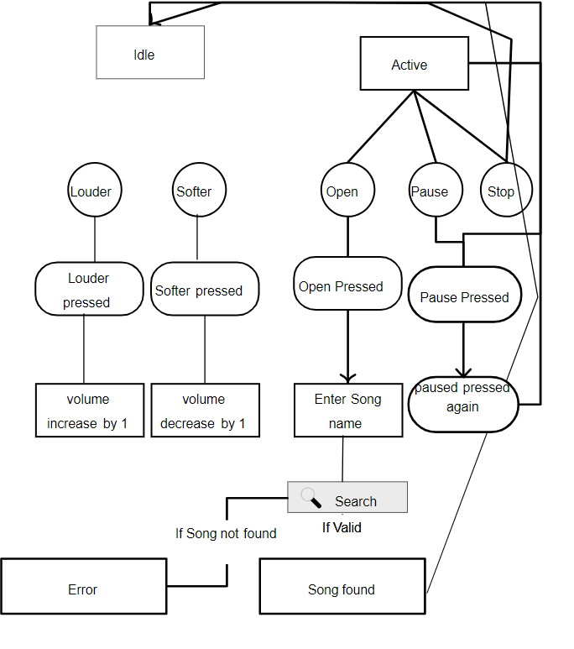This workflow ensures an efficient, user-friendly, and engaging experience for users of the **"Sangeet Online Music Playing Platform."**

### ****CHAPTER 6****

**PROJECT OUTCOME**

The **"Sangeet Online Music Playing Platform"** project achieves significant milestones in delivering a seamless, user-friendly, and innovative music streaming experience. By integrating search functionality, personalized recommendations, and an intuitive interface, the project caters to the diverse needs of music enthusiasts.

### ****6.1 Key Outcomes:****

1. **Enhanced Accessibility:**
   * Users can access their favorite songs, artists, and playlists anytime and anywhere, ensuring convenience across various devices.
   * Voice input functionality enables hands-free search, making the platform accessible to users with varying technical skills.
2. **Improved User Engagement:**
   * Personalized recommendations based on listening preferences enhance user satisfaction and encourage longer engagement with the platform.
   * Features like playlist creation and management foster a more interactive and enjoyable music experience.
3. **User-Friendly Experience:**
   * The platform's responsive design and intuitive interface ensure a smooth navigation experience for users of all age groups and technical expertise.
   * Seamless playback and on-the-go accessibility create a reliable and enjoyable user journey.
4. **Efficient Performance:**
   * Optimized database queries and fast-loading media streaming ensure high-quality and uninterrupted playback.
   * Leveraging advanced algorithms, the platform delivers accurate search results and relevant recommendations.
5. **Scalability and Flexibility:**
   * The system’s modular architecture allows for future enhancements, such as the inclusion of regional songs, podcasts, and offline playback.
   * Scalable backend design ensures the platform can accommodate a growing user base and additional features.

### ****6.2 Social and Cultural Impact:****

1. **Fostering Music Appreciation:**
   * The platform promotes diverse musical tastes by exposing users to global and regional music collections.
   * By recommending a variety of genres, it supports emerging artists and smaller music labels.
2. **Building Community Through Music:**
   * Users can share playlists, favorite tracks, and recommendations with friends and family, fostering a sense of community.
   * The platform contributes to the democratization of music by offering access to a broad catalog for users across different socio-economic backgrounds.
3. **Promoting Local Artists and Culture:**
   * By featuring Indian artists and regional music, the platform supports cultural preservation and enhances the reach of local talent.

### ****6.3 Technological Advancement:****

1. **Innovative Use of Machine Learning:**
   * The recommendation engine showcases the effective use of **AI and machine learning algorithms** in understanding user preferences and predicting relevant content.
2. **Seamless Integration of Advanced Features:**
   * The use of modern web technologies (HTML5, CSS3, Django) ensures a cutting-edge user experience with minimal latency.
   * Speech-to-text capabilities highlight the integration of advanced tools like **Google Speech API** for accessibility.
3. **Foundation for Future Expansion:**
   * The project lays a strong foundation for further research into audio streaming, voice-assisted interfaces, and AI-powered content curation.

### ****6.4 Measurable Outcomes:****

1. **User Satisfaction and Retention:**
   * High user retention rates and positive feedback on the platform’s design, recommendations, and usability.
2. **Cultural Impact:**
   * Increased exposure to regional and independent music, contributing to their popularity and sustainability.
3. **Performance Metrics:**
   * Minimal buffering, accurate search results, and smooth playback ensure technical reliability and an enhanced user experience.

The **"Sangeet Online Music Playing Platform"** not only meets its functional and technical objectives but also stands as a testament to how technology can enhance entertainment, promote cultural diversity, and create inclusive user experiences.

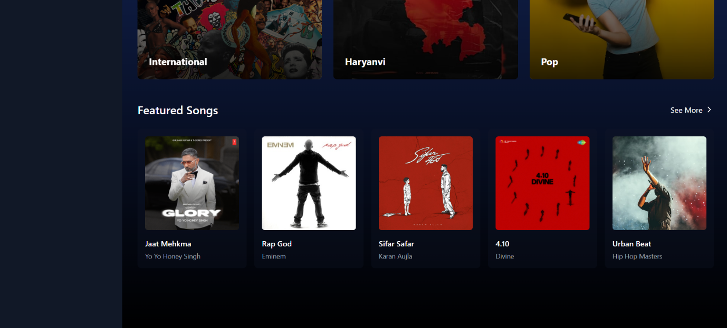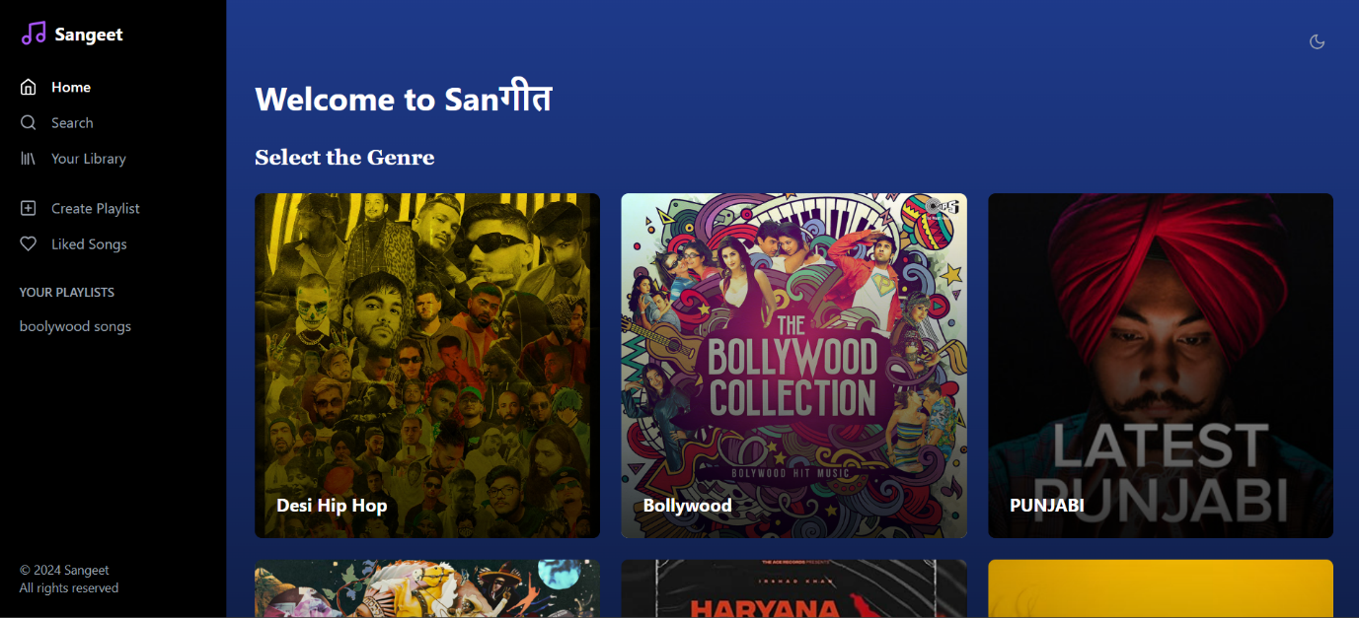

Figure 2

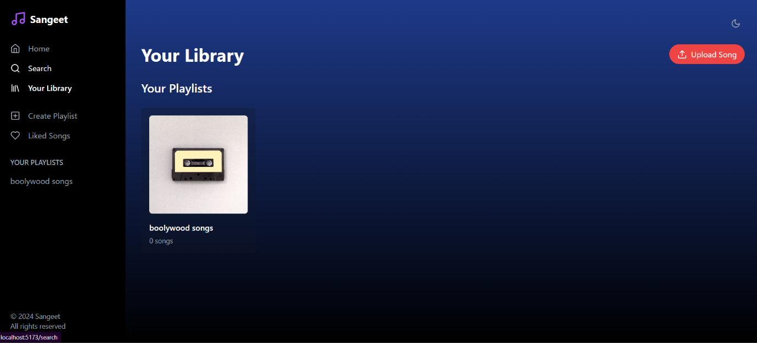

### ****CHAPTER 7****

**USER INTERFACE**

The **"Sangeet Online Music Playing Platform"** features a thoughtfully designed user interface aimed at providing an intuitive, visually appealing, and seamless experience. Each page and functionality has been structured to maximize accessibility, engagement, and usability.

### ****Home Page****

The **Landing Page** of the "Sangeet Online Music Playing Platform" serves as the entry point for users, providing a welcoming and functional interface. The page includes:

* A **bold header** with the title "Sangeet Online Music Playing Platform."
* A **navigation bar** featuring links to the Home page (default), Explore, My Playlist, Search, Sign-up, Login, Contact, and About sections for easy navigation.
* A **search bar** placed prominently in the center of the page, allowing users to search for songs, artists, or albums effortlessly.
* A **highlight section** showcasing trending songs, popular artists, and featured playlists, encouraging exploration.
* A **call-to-action button** labeled "Start Listening Now" for users to dive into the music library.

### ****Sign-up Page****

The **Signup Page** enables users to create an account, ensuring personalized access to the platform's features. It includes:

1. **Input Fields:**
   * Username: To create a unique identifier for each user.
   * Email: For communication and password recovery purposes.
   * Password: A masked field for security, validated for complexity (minimum length and special character requirements).
   * Confirm Password: Ensures the accuracy of the entered password.
2. **Form Validation:**
   * Ensures no field is left blank.
   * Validates the email format and password strength.
   * Displays error messages for mismatched passwords or invalid inputs.

At the bottom, a "Sign Up" button allows submission, with feedback messages confirming account creation or highlighting errors.

### ****Login Page****

The **Login Page** is designed for secure access to the platform. Unauthorized users attempting to access restricted sections are redirected here. Features include:

* Username/Email and Password input fields.
* "Forgot Password?" link for account recovery.
* A "Login" button to authenticate user credentials, with error prompts for invalid entries.

### ****Explore Page****

The **Explore Page** showcases a curated collection of music based on genres, moods, and trending songs. It includes:

* **Dynamic Categories:** Users can browse playlists like "Top Hits," "Relaxing Moods," or "Bollywood Classics."
* **Filters and Sorting:** Options to filter music by genre, language, or popularity.
* **Recommendations:** AI-powered personalized suggestions based on user preferences and listening history.

### ****Search Page****

The **Search Page** provides a real-time search interface with:

* A responsive search bar for typing song titles, artists, or albums.
* Auto-suggestions as the user types, offering quick results.
* Results displayed with song thumbnails, artist names, and play buttons for immediate access.

### ****My Playlist Page****

The **My Playlist Page** allows users to create, manage, and listen to their personalized playlists. Features include:

* **Create Playlist:** Users can name and add songs to playlists.
* **Edit and Delete Options:** Modify or remove songs and playlists.
* **Share Button:** Option to share playlists with others via social media or email.

### ****Playback Page****

The **Playback Page** is designed for an immersive music experience, featuring:

* A **media player** with controls for play, pause, skip, shuffle, and repeat.
* Song details (title, artist, album) displayed alongside album artwork.
* A **progress bar** and volume control slider for enhanced usability.
* Lyrics display (if available) synced with the song's playback for karaoke-style interaction.

### ****Contact Page****

The **Contact Page** provides:

* **Contact Information:** Includes email, phone number, and social media handles.
* **Contact Form:** Users can submit queries, feedback, or suggestions through input fields for name, email, subject, and message.

### ****About Page****

The **About Page** describes the purpose of the platform, its mission, and its features. It also highlights the team or individual behind the project, offering transparency and authenticity.

### ****Backend Admin Page****

The platform utilizes the **Node JS** for backend management. Features include:

* **User Management:** Admin can view, edit, or delete user accounts.
* **Music Library Management:** Add, update, or remove songs, albums, and playlists.
* **Analytics and Reports:** Access usage statistics, popular searches, and user activity logs.
* Secure, customizable, and intuitive interface ensures effective server maintenance and data management.

### ****References****

1. JavaScript Documentation - [https://developer.mozilla.org](https://developer.mozilla.org/)
2. Music Dataset for Testing - [https://www.kaggle.com](https://www.kaggle.com/)
3. Bootstrap Framework - [https://getbootstrap.com](https://getbootstrap.com/)
4. Cloudnary Management Console - <https://cloudnary.com>